Tetrafluoroethene compound project
Student Name
Institution Affiliation
Course Name and Course Number
Professor
Date

Molecule - Tetrafluoroethene

- Name/Names of the compound - include the IUPAC and any other common/traditional names that are used.

Name Tetrafluoroethene

IUPAC Name | 1,1,2,2-tetrafluoroethene
Alternative Names | Tetrafluoroethene  TETRAFLUOROETHYLENE  Perfluoroethylene  Perfluoroethene

- What are some interesting facts, common uses, and where is it commonly found? (summarized bulleted points are sufficient, maybe in a table?)

Compound name | Tetrafluoroethene
Interesting facts | - Tetrafluoroethylene is a colourless, and odorless gas.  - Like all unsaturated fluorocarbons, it is susceptible nucleophilic attack.  - It is unstable towards decomposition to carbon and carbon tetrafluoride (CF₄)  - Prone to form explosive peroxides in contact with air.  - TFE reacts with oxygen at low temperatures to form an explosive oxide
Common uses of the compound | - This gaseous species is used primarily in the industrial preparation of fluoropolymers.  - TFE is also used in the preparation of numerous copolymers that also include hydrogen and/or oxygen
Commonly found in | - TFE is manufactured fromm chloroform.  - Chloroform is fluorinated by reaction with hydrogen fluoride to produce chlorodifluoromethane.  - Pyrolysis of chlorodifluoromethane then yields TFE.

- Is the chemical hazardous, what safety precautions/PPE are required when working with it or exposed to it?

The chemical is hazardous;
Major health hazards include:
Eye irritation, difficulty breathing, suspect cancer hazard (in animals)
Physical hazards:
May explode when heated. flammable gas. may cause flash fire.
Flash back hazard.
May polymerize. containers may rupture or explode.

Safety precautions when working or exposed to Tetrafluoroethene
Eye protection: wear splash resistant safety goggles with a face shield, provide an emergency eye wash fountain and quick drench shower in the immediate work area.
Gloves: wear appropriate chemical resistant gloves.
Ventilation: ventilation equipment should be explosion-resistant if explosive concentrations of material are present.
Respirator: under conditions of frequent use or heavy exposure, respiratory protection may be needed.

- What are some applications of your chosen chemical? What is it used for in industry or in research? What WAS it used for historically (in the past)? Are there future research possibilities?

Applications of tetrafluoroethene
- Is used primarily as a refrigerant for “high-temperature” refrigeration, such as domestic refrigerators and automobile air conditioners.
- Propellant for pharmaceuticals;
- Blowing agent for foams.
- Used in medical inhalers research and tested in blood samples
- Used as a solvent in research activities
Uses of tetrafluoroethene historically
Used in containers and pipework for reactive and corrosive chemicals.

There are research possibilities of tetrafluoroethene that are yet to be discovered and others are need to research on its reactivity and uses as a compound in the chemical industry and also in its health effects.

l

- Using an image of the structure (Above), state the shape around EACH 'central' atom (there may be many!) - basically all atoms except hydrogens.

The central atom in this compound is carbon and its shape is trigonal planner and also tetrahedral geometry due repulsion of the atoms

- Include the hybridization around EACH ‘central’ atom?

The hybridization of carbon as the central atom is sp2, sp3

- Polarity Analysis
  - Using electronegativity values/calculation and an explanation, determine the BOND polarity. Include bond dipoles (��⁺/��⁻) where appropriate.

Intermolecular forces mainly involve polar molecules, but Teflon is a non-polar molecule. Therefore, it cannot have dipole-dipole or hydrogen bonding acting upon its molecular structure. The negative fluorine from the (C2F4) n is attracted to the positive hydrogen in the H2O.

  - Determine if the molecule is polar. Include the molecular dipole, if there is one. Explain fully, relating to your analysis from a.
The molecule is non polar.
A molecule may be nonpolar either when there is an equal sharing of electrons between the two atoms of a diatomic molecule or because of the symmetrical arrangement of polar bonds in a more complex molecule.

- List at least 5 physical properties of the compound.
Tetrafluoroethene
Molar mass | 100.016 g/mol
Appearance | Colourless gas
Odor | odorless
Density | 1.519 g/cm³ at -76 °C
Melting point | −142.5 °C (−224.5 °F; 130.7 K)
Boiling point | -76.3 °C
Solubility (in water). | Slightly soluble in water

- Compare the boiling point of your compound to THE alkane (C_{x}H_{y}) that is closest in size ('close to the same' molar mass/# of electrons, ask me if you aren't sure) and explain any differences by discussing the intermolecular forces present for both molecules.

For a given molar mass, the boiling points of alkanes are relatively low because of the amount of energy required to break the bonds is low as compared to 1,1,1,2-tetrafluoroethane with a high molecular mass and double bond which require more energy to break the intermolecular forces between the atoms.

- Reactions involving tetrafluoroethene
- What reaction forms the compound (if there is one)?
- What reactions does this molecule undergo?
- Include complete structures and names for all reactants and products. Give the type of reaction for each.

  - Include structures and names for all reactants and products.

Polymerization reactions
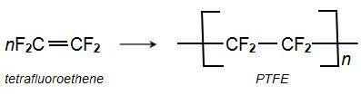
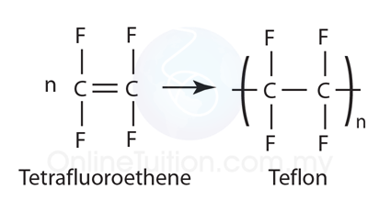

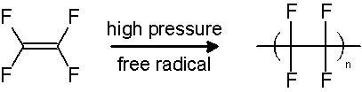
Tetrafluoroethene
Polytetrafluoroethylene

  - Draw a potential energy diagram to show this reaction.

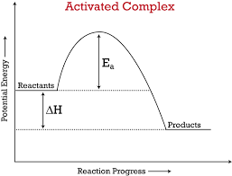

  - Find the enthalpy of combustion per mole of your compound using BOTH of the following methods;
    - Using bond energies
Enthalpy of formation of Tetrafluoroethene,
C2F4 (g), -675.00 kJ/mol,

    - Using enthalpies of formation.
Δ_{f}H°₌ -658.56 kJ/mol

Reversable reaction
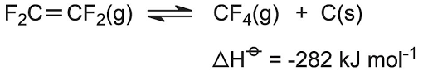

  - Compare these answers from c) and explain any differences. Which is more accurate and why? Add the more accurate value to your potential energy diagram drawn for b).

The enthalpy value obtained by the enthalpies method is lower as compared to the other one.

- If 10.0g of your compound is burned and used to heat 2.0L of water with an initial temperature of 20.0ºC, what is the final temperature of the water? Use the most accurate answer for the enthalpy of combustion from your calculations in #11. c.

using q= m x cp x Δt calculates the energy change for quantities used
mass =10g
q=-675kj/mol
c=2000
=675kj/mol=10/1000kg x2000 xΔt
Δt=337.2k
t=337.2k-273k= 64.2ºc
final temperature= 64.2-20=44.20ºc,

- Since not all of these molecules are the same difficulty for orbital overlap diagrams, draw an orbital overlap diagrams for ethanal and ethanol. These are to be hand drawn. Be sure to label each orbital and each bond the way you have been taught. Finally, briefly explain why these molecules have such different bonding arrangements when their names and formulas are so similar.

